**Product Name**

Restaurant reviews

**Problem Statement**

Create an application which can help users to search for a restaurant and view other user reviews about it. Users can add their review about a restaurant which can be viewed by other users of the application. The application will also allow users to conveniently book tables online.

**Objective**

Implement a web application where users can search for restaurants and view reviews about it. User can login to add a review about any restaurant. Application also allows users to make reservations.

**Functional Requirements**

1. Signup

2. Login

3. Logout

4. Search Restaurant

5. Add review

6. Delete/edit review

7. Add restaurant

**Non Functional Requirements**

1. Display 5 reviews per list

2. Application must work on all browsers

3. Session management

4. Email for confirmation of reservation

5. User must confirm booking in 5 minutes

**Use Case Diagram**

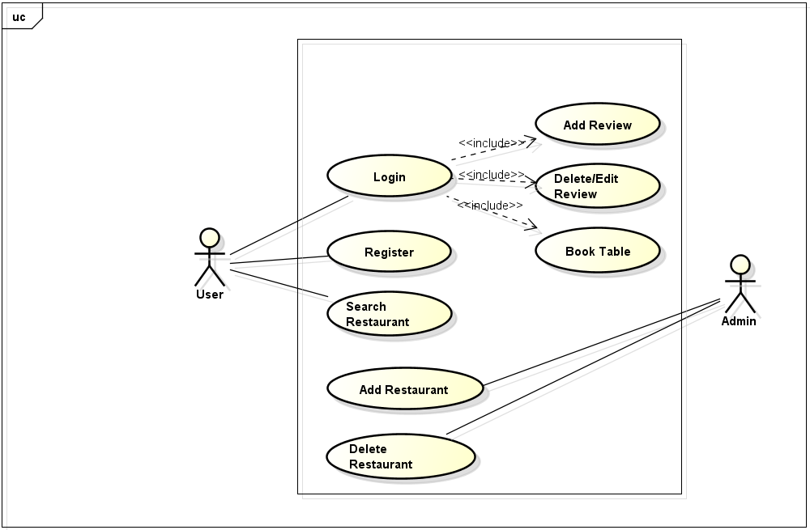

**Use Case Description**